|  |  |
| --- | --- |
| CAC logo | **Year 11 ATAR Human Biology**  **Task 2 – Development of the Foetus** |

|  |  |  |  |
| --- | --- | --- | --- |
| **Name: Marking Key** | **Teacher:** Ms Langford-Davis | **Date:** | **Score:** /30 |

**Assessment type:** Science Inquiry – Investigation

**Background Information:**

Complete development of a human foetus takes about 38 weeks. Increases in size and mass are two of the many changes that the foetus undergoes. These increases do not occur at the same rate. Many factors affect the birth size of a human baby, but there is an average mass and an average length standard for each stage of development. The approximate age of a foetus can be determined from its mass and length.

In this activity, you will measure foetal images of various ages and complete a data table. From this data and data you are given concerning foetal mass, you will construct and interpret a graph of foetal size verses gestational time.

**Objectives:**

* Calculate the length of a human foetus at various stages of development.
* Graph the length of a developing human foetus.
* Graph the mass of a developing human foetus.
* Determine the period of foetal development during which the greatest changes in mass and in length occur.

**Materials:**

* Metric ruler
* Pencil, eraser
* Calculator

**Procedure:**

1. Examine ***Figure 1***.
2. It shows six stages of a developing human foetus. The stages are shown at 40% of the foetus’s actual size.
3. Study the lengths indicated on the diagram of the 38-week foetus and use these as a guide to measuring the other diagrams.

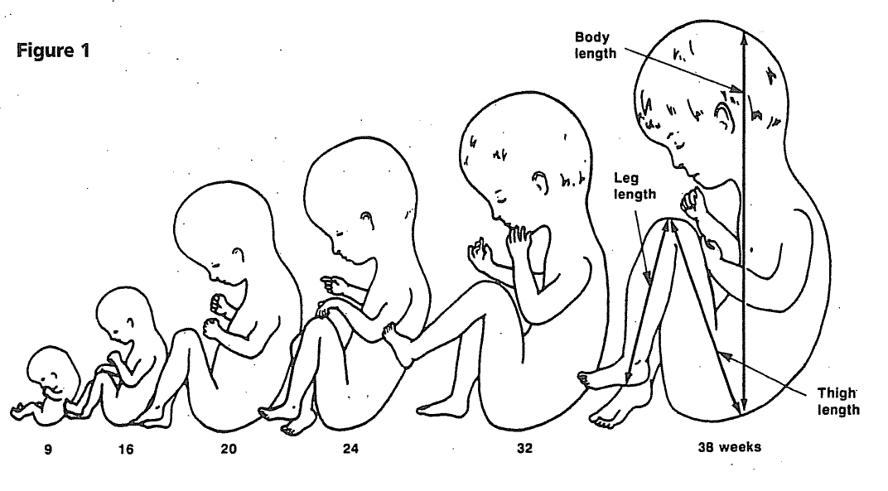**Procedure:**

1. Measure each length listed below in millimetres. Record your data in the spaces provided in Table 1.
   1. Measure the body length from the rump to the top of the head.
   2. Measure the thigh length from the rump to the knee.
   3. Measure the leg length from the heel to the knee.
2. Add the measurements for each stage together. Record the total length in the space provided in Table 1.
3. Multiply the total by 2.5 to give a figure that is close to the actual length of the foetus at each stage. Record the actual length in Table 1. (6 marks)

**Table 1** 1 mark for each correctly completed row (+/- 5mm)

|  |  |  |  |  |  |
| --- | --- | --- | --- | --- | --- |
| **Length of a Developing Foetus** | | | | | |
| **Age of Foetus**  **(in weeks)** | **Body Length**  **(mm)** | **Thigh Length**  **(mm)** | **Leg Length**  **(mm)** | **Total Length**  **(mm)** | **Actual Length**  **(mm)** |
| **2** | - | - | - | - | 2 |
| **9** | 16 | 5 | 5 | 26 | 65 |
| **16** | 28 | 12 | 10 | 50 | 125 |
| **20** | 50 | 23 | 20 | 93 | 232.5 |
| **24** | 59 | 25 | 22 | 106 | 265 |
| **32** | 69 | 32 | 25 | 126 | 315 |
| **38** | 80 | 44 | 36 | 160 | 400 |

Table 2 shows the changes in the mass of 44a developing foetus from 4 – 38 weeks.

**Table 2**

|  |  |  |  |
| --- | --- | --- | --- |
| **Mass of a Developing Foetus** | | | |
| **Time**  **(weeks)** | **Mass**  **(grams)** | **Time**  **(weeks)** | **Mass**  **(grams)** |
| 4 | 0.5 | 24 | 650 |
| 8 | 1 | 28 | 1100 |
| 12 | 15 | 32 | 1700 |
| 16 | 100 | 36 | 2400 |
| 20 |  | 38 | 3300 |

**Graphing the Length and Mass of a Developing Foetus**

1. Graph the data for foetal length and mass using the graph paper provided, then answer the following questions in the spaces provided. (6 marks)

Title (1), Scale (1), Labels & units x (1), Labels & units y (1), Plotting (1), Graph (1)

1. During which weeks of development is the baby termed a foetus? (1 mark)

________________At 9 weeks until birth______________________________________

1. What is the actual length of the foetus at week 9? ___65mm___(accept 60-70)___ (1 mark)
2. How much mass does the foetus gain from 0 to 8 weeks of development? (2 marks)

______________________1 gram_______________________________________________

1. Using your graph:
   1. Identify the time period in which the foetus shows the greatest increase in actual length. Explain your answer. (2 marks) _________Weeks 16 to 20 (1)
   2. mm in 4 weeks (1)____________________________
   3. Identify the time period in which the foetus shows the greatest increase in mass. Explain your answer. (2 marks)

_________Weeks 36-38 (1) 112g in 2 weeks (1)

__________________________________________________________________________________________________________________________________________________________________________________________________________________

1. Suggest a reason why the length of a foetus increases more rapidly than the mass of a foetus.

(1 mark)

__________Suggestions will vary_____

___________________________________________________________________________

1. At which week does the foetus reach: (2 marks)
   1. About half its full length? _______~ Week 19__________________________________
   2. About half its full mass? ________Week 32___________________________________
2. Name the process which increases cell numbers as the baby grows. _mitosis_____ (1 mark)
3. Estimate the week of gestation if a baby is born prematurely with a mass of:
   1. 2200 grams. ____Week 35________________________________ (1 mark)
   2. 1800 grams. ____~Week 33_______________________________ (1 mark)
4. What is the mass of the developing foetus at 20 weeks? __~300g__________ (1 week)
5. The ultrasound image below has a CRL (crown-rump length) measurement of 125mm. Estimate the FL (femur length) and week of the pregnancy. Justify your answer. (3 marks)

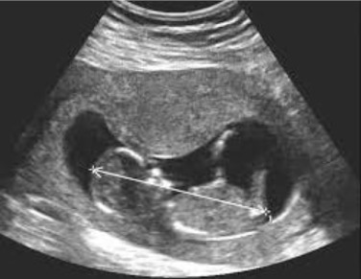

________12mm____________________

________~16 weeks________________

Answers will vary________________________________________________________